Eservice Express Feedback – 0609

1. Remove the menu items which not exist. 0614已修改

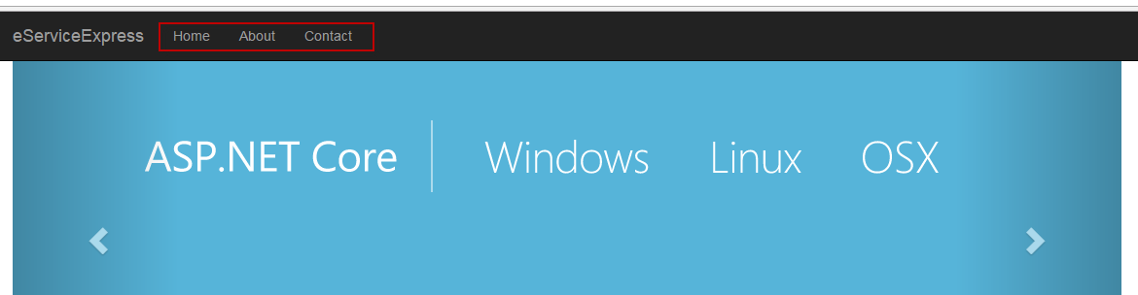

1. When eService Application open an eService Express page, use Chrome browser to open. Internet Explorer not working properly always.

So the logic can be, if Chrome exists, use Chrome, otherwise use whatever browser which is default by user’s computer.

For testing, please focus testing with Chrome.

问题：是否要将加一个逻辑：如果用户电脑上装了Chrome则用Chrome，如果没有装则选择默认的浏览器打开？

1. I found a computer have eServiceExpress installed, the webpage can pop up, and quantity can be changed. But after click the “Save” button, the page is not refreshed, it looks like the change is not saved.

问题：在本地测试问题未重现，当在web页面修改quantity后点击save按钮可以保存